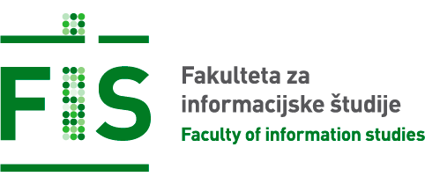

Exercises Report - Lab 2
LAB 2 -IDENTIFYING AND PREVENTING PHISHING ATTACKS

Course: Cyber Security

Ljubljana, 23/5/2026 Vishnu Viswanath Thattrakkal
Student ID- 35250024

LAB 2 -Identifying and Preventing Phishing Attacks

INTRODUCTION
Phishing is one of the most common social engineering techniques used by attackers to trick users into entering their login information on a fake page. The goal of this exercise is to learn what such pages look like, how they work, and the importance of recognising the signs of an attack. The goal is for users to learn how to: recognise typical signs of a phishing site, simulate a phishing attack using SET, analyse the captured data, understand the limitations, and raise awareness of the importance of checking URLs and security indicators.
For the lab exercise, I needed to create an HTML file for testing. As per the instructions, the file was named login.html on the computer
File -01
Step 2
Launching setoolkit in the terminal on a Linux system, as per the instructions, selecting appropriate options for website cloning to steal data from the user or customer, such as usernames and passwords.
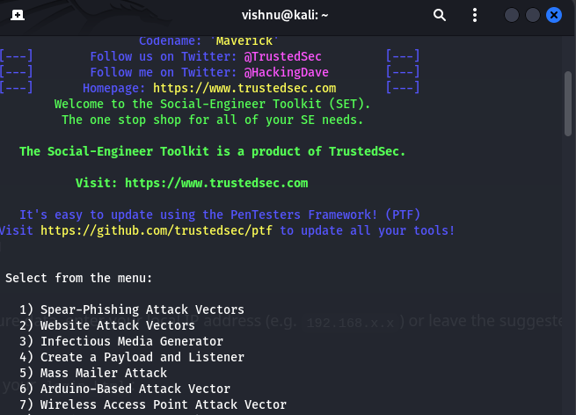
(Image -01)
1) Social-Engineering Attacks> Website Attack Vectors>Credential Harvester Attack Method>Site
Cloner
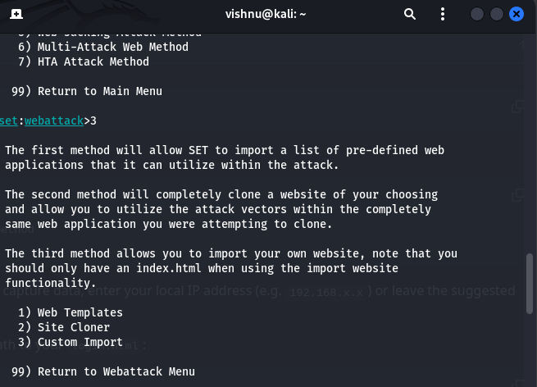
(Image -02 )

- When asked for an IP address to capture data, I entered my local IP address. For the cloning URL, enter the path to login.html. With this, it will set a fake page and start listing on port 80

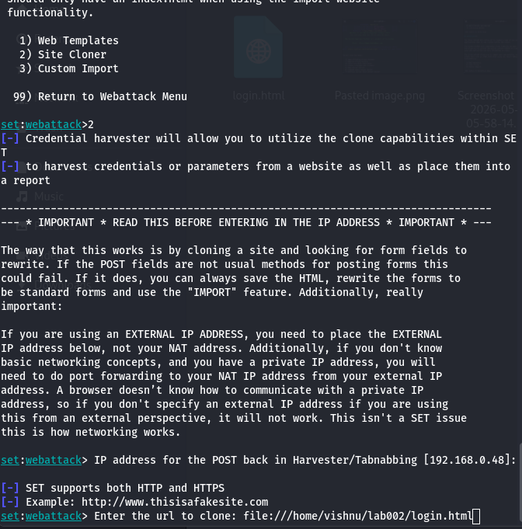
(Image -03)
- Using this, cloning can be done and the data, like usernames and passwords of unsuspecting users
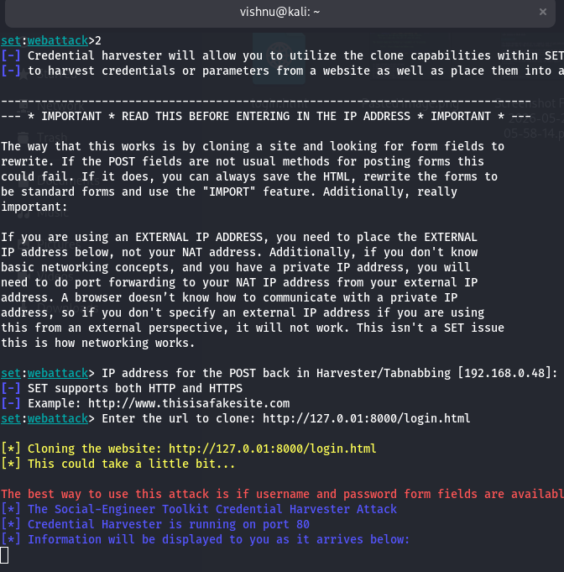
Image -04
- As shown in the picture below (image 05), the cloned website is hosted for testing, and data will be collected as the username and password are entered in the login page.

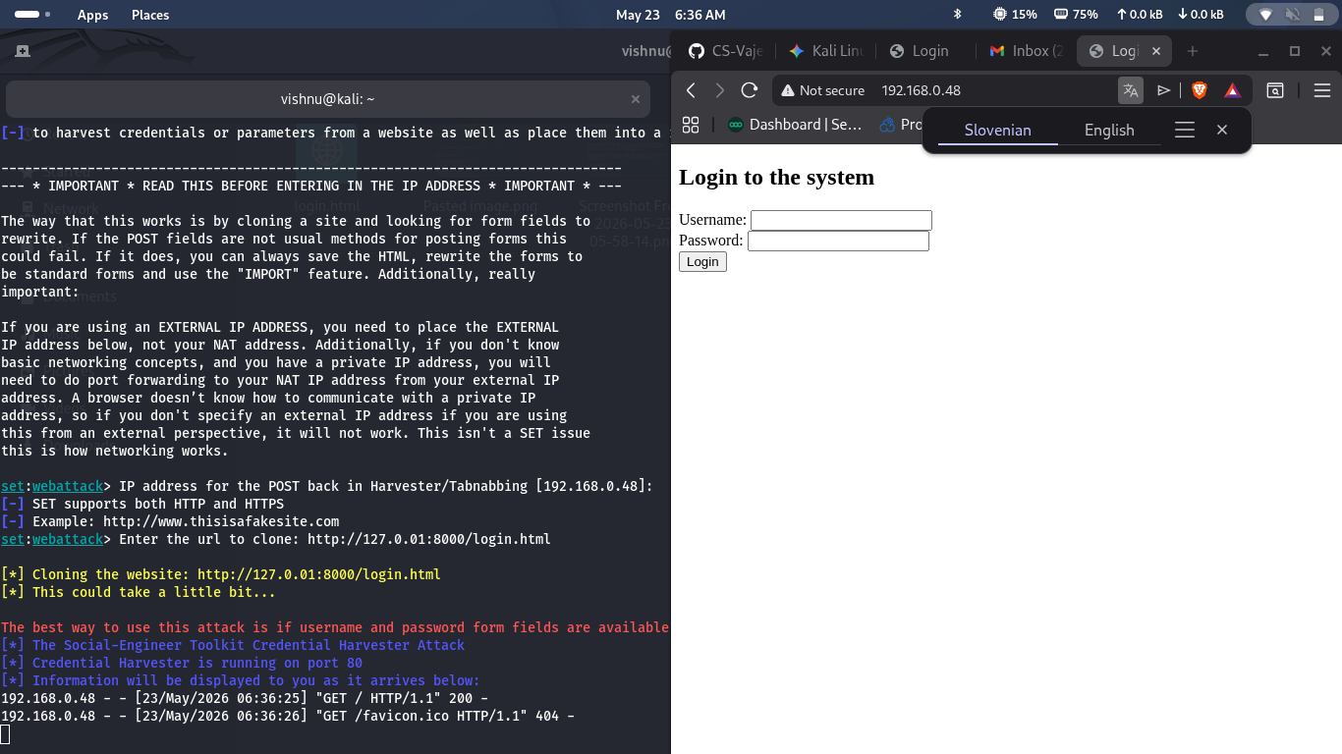
Image -05
- After the password and username are added to the cloned website, it captures the password and username in the terminal, which is shown in image-6.
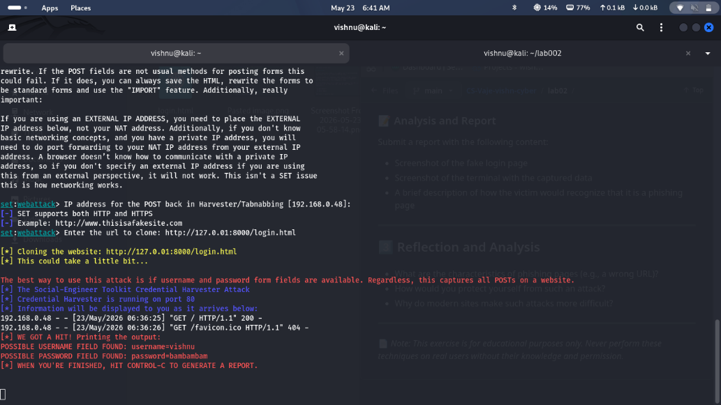
Image -06

Reflection and analysis

Phishing websites are a common cyber threat that most people encounter online. If we are not careful, it is easy for data to be stolen by cybercriminals. The exercise demonstrates how easy it is to steal data from a user. There are ways to notice these fake websites, which include
- The website URL is different from the official domain.
- Spelling mistakes or poor design on the page.
- Unexpected login requests or urgent messages.
- Missing HTTPS security lock icon.
- Strange pop-ups or requests for sensitive information.
- The email or message linking to the page creates pressure or fear.
The ways to protect yourself from phishing attacks
To stay safe from phishing attacks, users should carefully check website URLs before entering credentials, use multi-factor authentication (MFA), avoid suspicious links or attachments, verify messages directly with official companies, keep browsers and antivirus software updated, use password managers to help detect fake websites, and remain cautious of urgent or emotionally manipulative messages.
Why modern sites make phishing attacks more difficult
Modern websites and online services make phishing attacks more difficult by using HTTPS encryption, browser security warnings, multi-factor authentication (MFA), advanced spam and phishing detection systems, login alerts, suspicious activity monitoring, domain and email authentication technologies such as SPF, DKIM, and DMARC, security-focused browser protections, and user education and awareness campaigns.

